CHAPTER 2: Getting into genes
Worksheet 2.6

Mendel’s experiments
Student: Class:

Green and yellow seeded peas
1. Gregor Mendel experimented with pure breeding yellow-seeded and green-seeded pea plants. He pollinated the flowers of the yellow-seeded variety with pollen from the green-seeded variety.
The results for the first generation (F₁) are shown in the diagram.
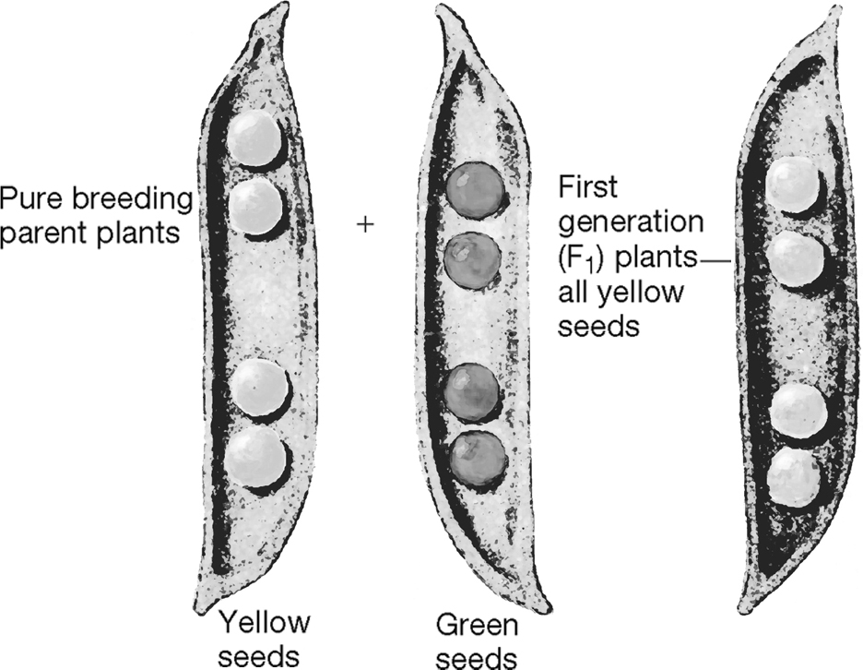
(a) Identify which gene is dominant for seed colour. .................................
(b) Use a Punnett square to show that all F₁ plants should be yellow seeded. Use suitable letters for the seed colour characteristic.

(c) Are the F₁ generation hybrid or pure breeding? ..............................................
(d) The F₁ generation are now interbred. Use a Punnett square to predict the proportion of phenotypes observed in the second generation (F₂).

Round and wrinkled seeds
2. Mendel conducted further experiments on pea plants with round seeds or wrinkled seeds. He found that round seeds (R) were dominant to wrinkled seeds (r).
Complete the Punnett square to predict the proportion of phenotypes when hybrid pea plants are crossed with pure breeding wrinkled seed plants.

